**Shopping Project Details**

**\*\*\*\*\*\*Home page / site :-**

* products – products under each category , sub category
* product categories : Fruits & Veg , Food grain , Oil Masala , Bakery , Snacks , Branded etc.
* offers : 50% off , 60% off etc.
* list of products
* Product detail : name , price , weight , image , colours etc.
* product detail page
* ( ref : <https://www.bigbasket.com/> )

**\*\*\*\*\*\*Sort and list shown by:-**

* Banners – images advertise
* Best sellers
* Most Popular
* Top offers
* Daily Sample
* Seasonal
* Monsoon must have
* Category wise on home page
* Brand store
* Feature receipt

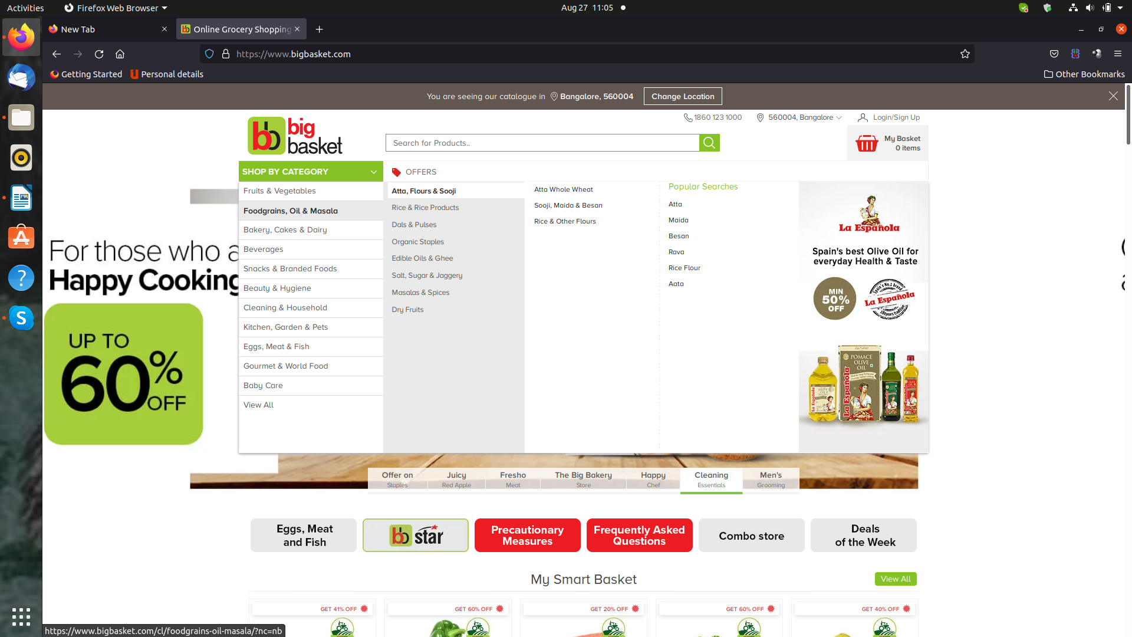

**\*\*\*\*\*\*\*\*Side menu selection:-**

* Category / sub category
* Brand
* seasonal
* country of origin
* price
* Discount
* Pack size

**\*\*\*\*\*\*\*\*\*\*Other:-**

* searches – by product , prices , offers
* ratings & review
* similar products

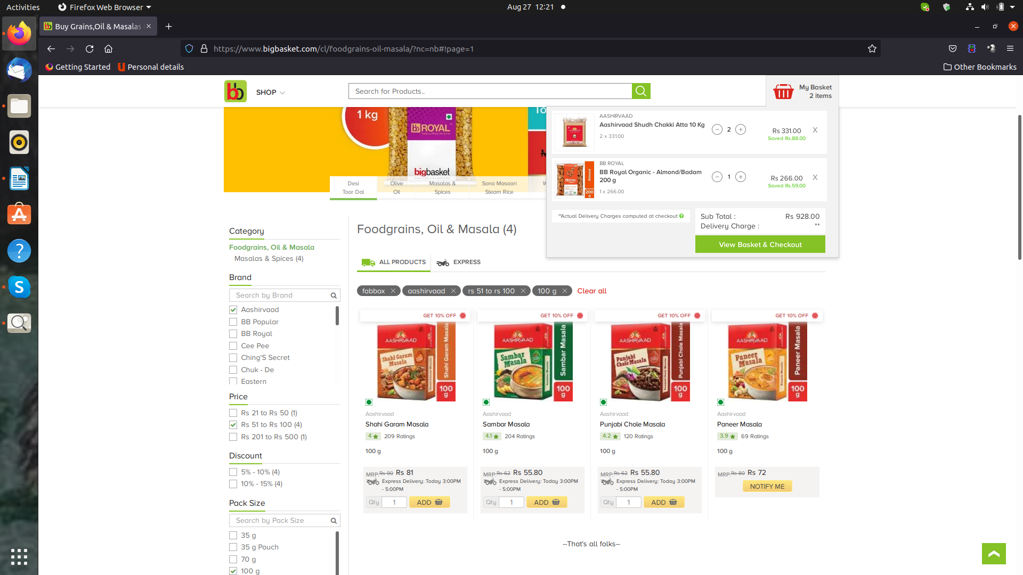

**\*\*\*\*\*\*\*\*\*Basket / Cart :-**

* Item name
* item description
* price
* quantity
* total

**\*\*\*\*\*\*\*\*Checkout and Payment:-**

* Checkout details
* Payments – payment integration

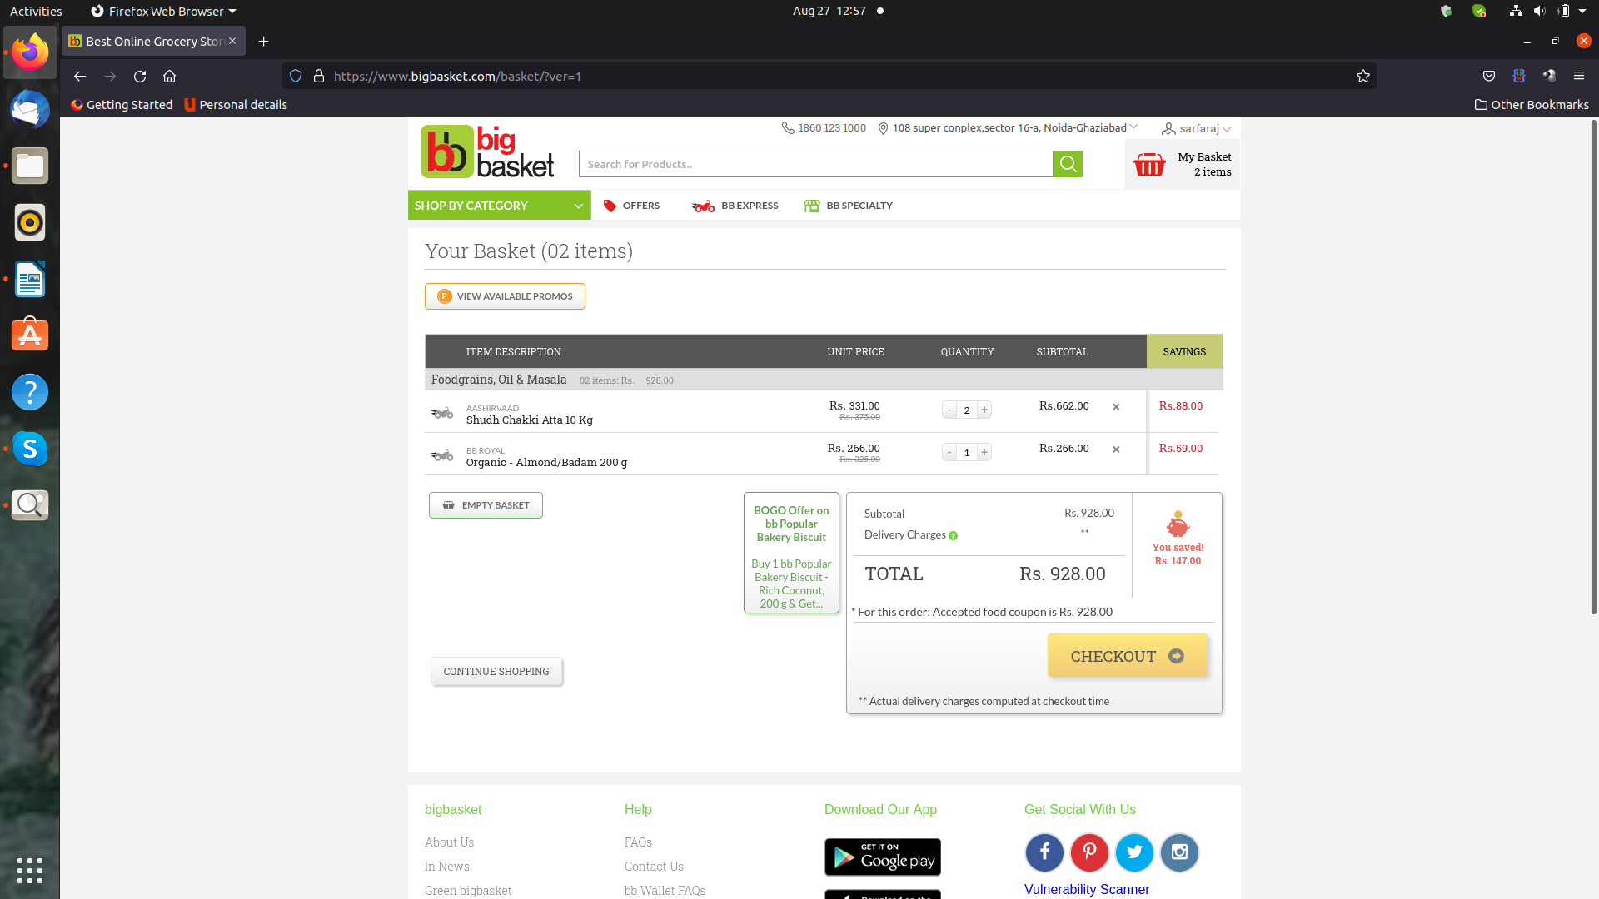

**\*\*\*\*\*\*\*\*User Account :-**

* Login Logout
* profile – name
* address
* phone
* email
* my orders list
* my wallet
* my payments
* notifications
* my gift cards

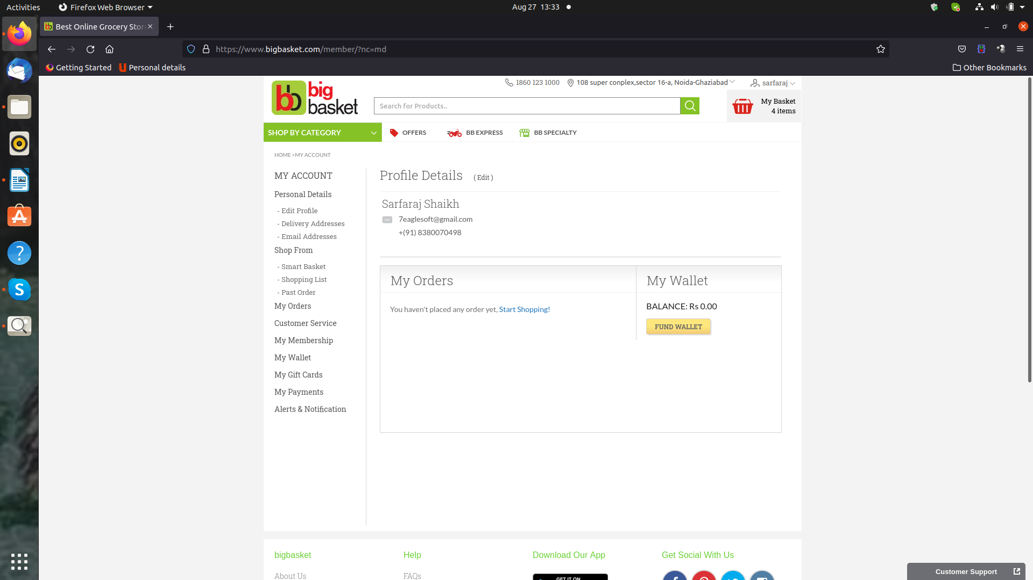

**Seller :**

* Login Logout
* profile – name
* company
* address
* phone
* email
* Add Product – name , price , size , brand etc
* Add Product – details
* Add Offer
* Orders approve
* Dispach list
* Delivered list
* Stock
* Notificatons

**SuperAdmin:**

* Login Logout
* profile – name
* company
* address
* phone
* email
* Approve seller or auto on purchase package
* Seller list
* Add category sub category
* List category
* Add Brands
* Product list
* Stock
* Orders
* Package size
* Notifications list
* Best Sellers – select / auto
* Top offers – select / auto
* Most Popullar – select / auto
* Daily --
* Mansoons – select / auto